Big Dreams Small Spaces Application

We work at Dacorum Education Support Centre which is a Pupil Referral Unit for KS3/KS4 students. Our site is based in Grove Hill, Hemel Hempstead, Hertfordshire and the students who attend have been permanently-excluded or are at risk of exclusion for a variety of reasons. They follow a twin track pathway enabling them to study for their GCSEs as well as providing support and guidance for their personal development.
We are passionate about horticulture and have four Year 10 students who have also expressed an interest in gardening. At present they help look after the indoor plants, create floral displays and maintain the courtyard area, which is proving to be a successful therapeutic and educational part of their timetable. Not only does it teach them new skills but it also enables a time for reflection and mindfulness and hopefully help them to stay out of trouble. We remember your TV Programme ‘Growing Out of Trouble’ and feel we are trying to achieve the same kind of results to prevent our students spiralling out of control with their personal lives.
We moved into a new building nearly 2 years ago and have managed to create a gardening haven in the central courtyard (see photos below). We did this last year during an activity week where staff and students created working parties and focused on several projects around the centre. This included: an Art project creating a mosaic display of tiles around a water feature, in woodwork making benches and planters for the courtyard, in horticulture creating hanging baskets, fillng the planters with plants and putting plants around the outside of the building. The students worked with staff in teams and all invested their ideas on ways to improve their environment.

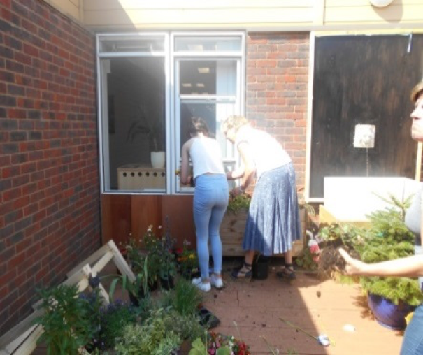
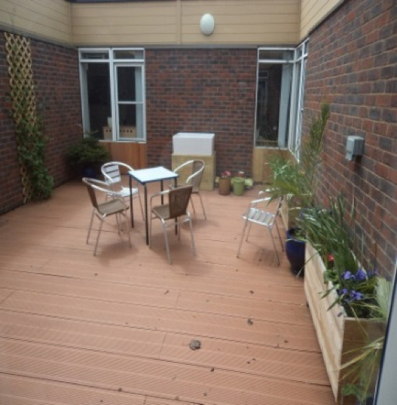
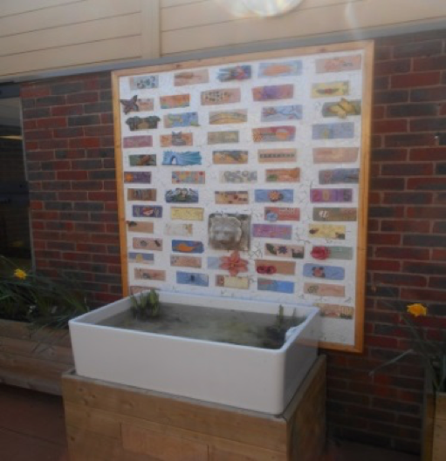

However, for the next stage we desperately need some advice, guidance and expertise to enable us to continue with the project with the outside space.

The Plot:

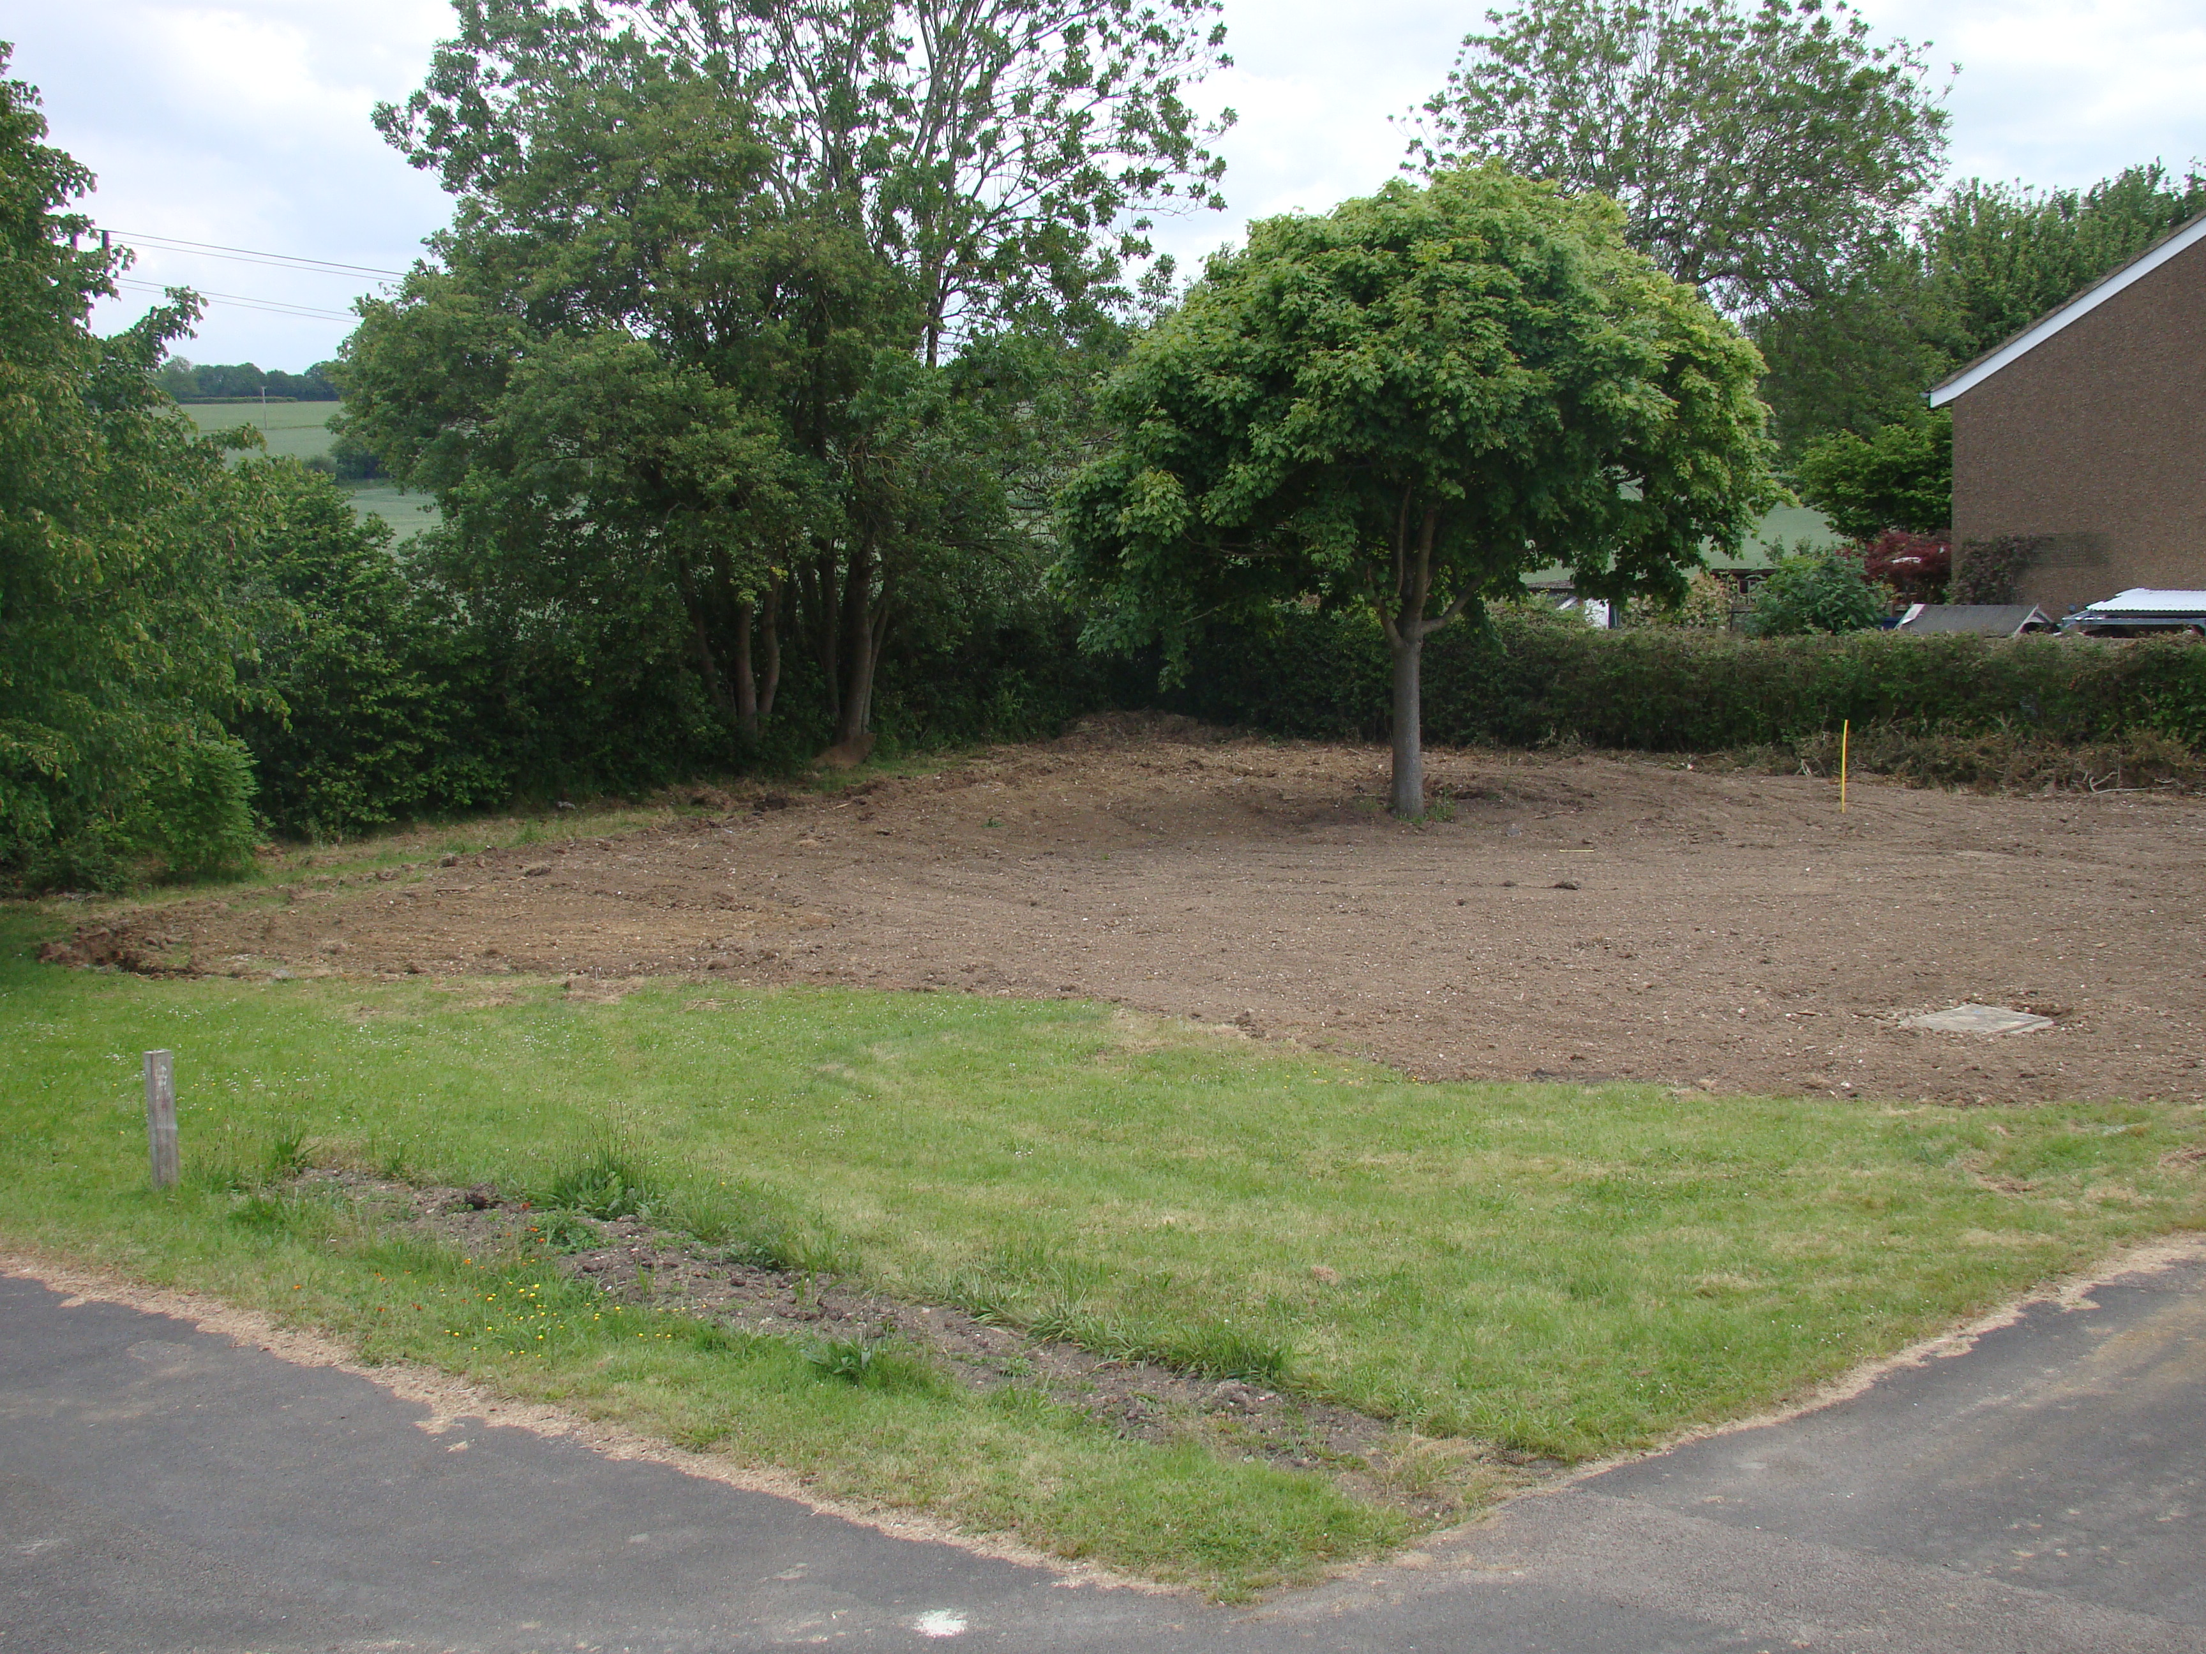
The area is approximately 25 x 28 metres and at present is grassed over with some established trees, bushes and hedges. We have recently planted a new hedge, using young plants obtained from the Woodland Trust.
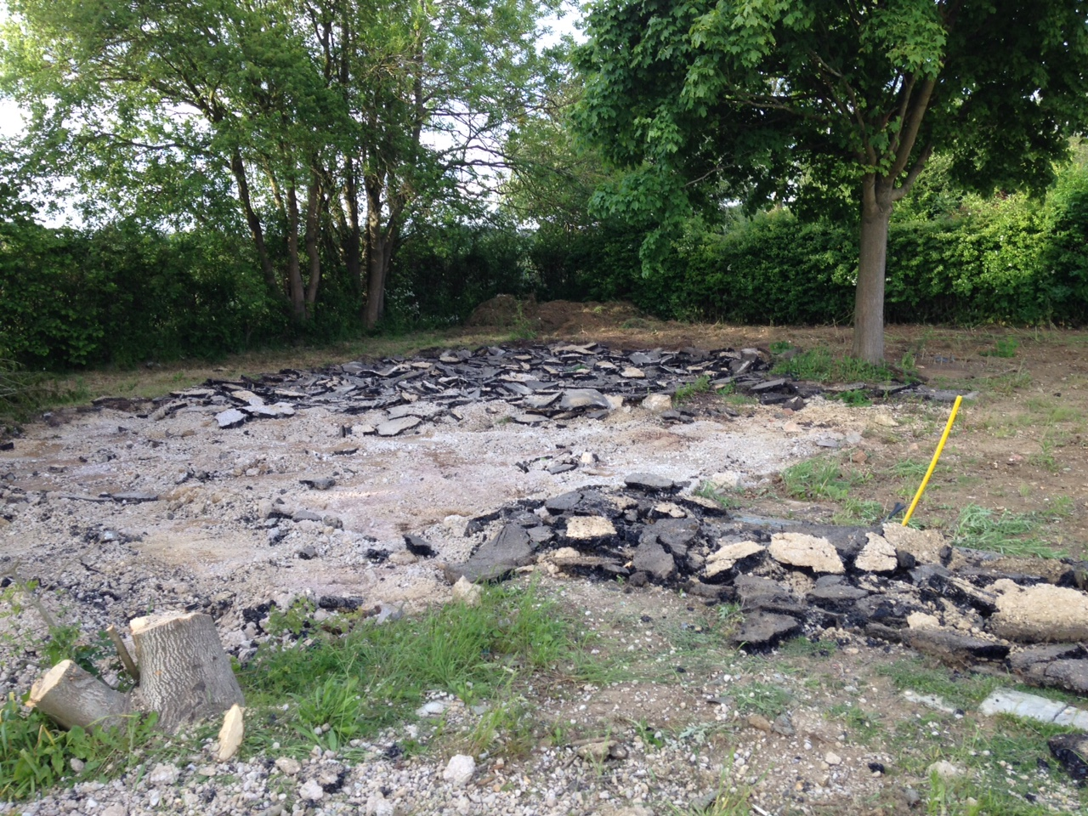

The Dream:

We wish to create a space that is dual purpose. An area for reflection and relaxation, a possible teaching space and provide produce and flowers to be used in lessons. We are passionate about making our site even more relaxed for the students so they can maximise their potential and continue to make the right choices in life would be our goal.
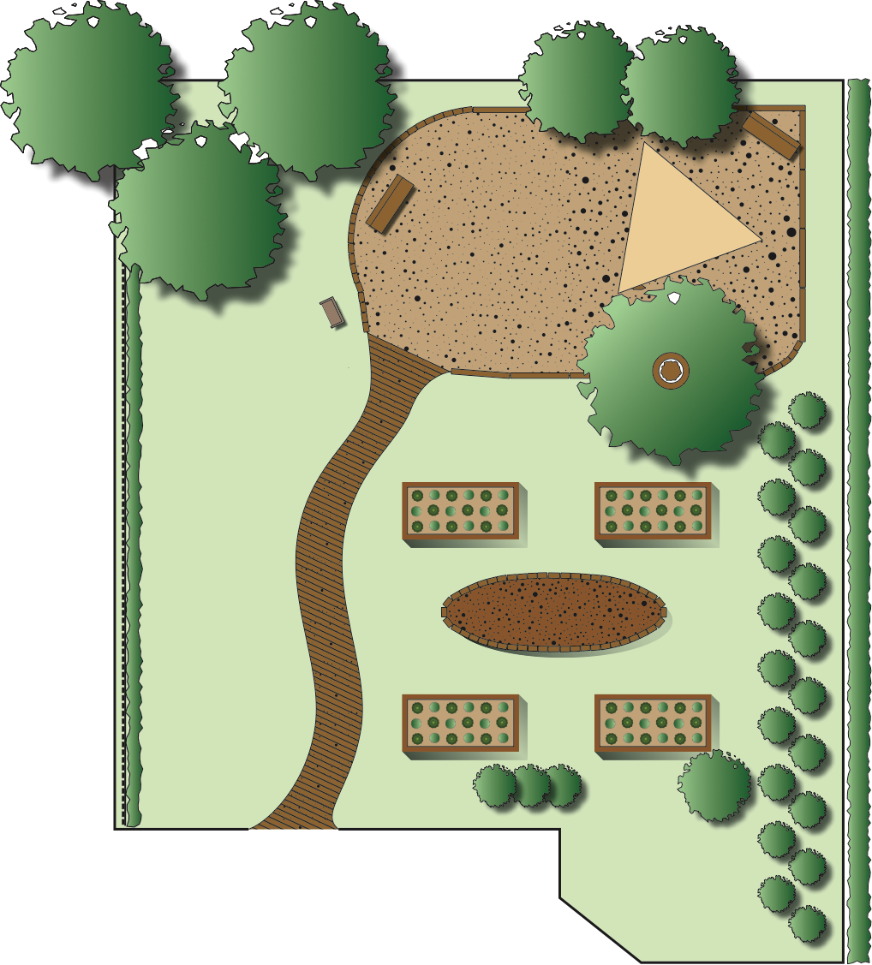
Over the past year we have come up with numerous ideas on how to develop the area with lots of input from various staff and students. We have even created a plan of a possible layout (see attachment). However, we need some expertise on how to realise our dreams. The things we definitely require are:
• Seating areas
• Grass area for outdoor games
• Flower beds for cut flowers to have around the centre
• Planting scheme to maximise flowering of plants during term time, particularly May through to July, and Autumn from September
• Vegetable beds for produce to use in Cookery classes
• Water feature (wildlife pond) or ideally a pond with a waterfall/fountain
• Garden shed
• Greenhouse

The Logistics:

As well as your much-needed input, the work would be done by our students, staff, plus any passing ‘volunteers’. We are planning an activity week at the beginning of July where the new students would be expected to participate in various projects alongside staff. We also have an impressive woodwork department, who are able to make benches, raised beds, decking etc and maybe even design a garden shed. The Art department could be working on an art installation possibly a sculpture.

The Budget:

We want to be able to create the garden space on as low a budget as possible and believe we could do it on around £5,000, including wood for benches, plants, bedding soil, pond pump etc. We have forks, spades etc and a potentially large workforce who won’t trouble the budget at all. We have the enthusiasm but would love to have your garden design and planting ideas to turn our dream into reality.

Gill Caslake (Drama Teacher and Curriculum Co-ordinator)
Chris Stacey (Learning Support Assistant)

